Tutorial 2

1. **What is a Distributed System?**

A *distributed system* contains multiple autonomous computers that are connected through a network and a distribution software which is middleware to allow computers to share system resources with each other and coordinate activities.

1. **List THREE (3) characteristics of a Distributed System.**

* The users perceive the system as a single, integrated computing facility.
* The components are autonomous.
* Scheduling and other resource management and security policies are implemented by each system.

1. **What does Remote Procedure Calls (RPC) support?**

RPC supports inter-process communication(IPC) and allows a procedure on a system to invoke a procedure executing in a different address space (commonly on a remote system).

1. **Give and explain any THREE (3) desirable properties of a Distributed System.**

**Access transparency**

Local and remote information objects are accessed using identical operations

**Location transparency**

Information objects are accessed without knowledge of their location

**Concurrency transparency**

Several processes run concurrently using shared information objects without interference among them

**Replication transparency**

Multiple instances of information objects are used to increase reliability without the knowledge of users or applications.

**Failure transparency**

The concealment of faults

**Migration transparency**

The information objects in the system are moved without affecting the operation performed on them.

**Performance transparency**

The system can be reconfigured based on the load and quality of service requirements.

1. **Explain the term Concurrency from the perspective of Distributed System.**

**Concurrency** can be defined as multiple activities that execute simultaneously, exploited by application software to speed up computation and to allow a number of clients to access a service. From the perspective of distributed systems, distributed applications use concurrency extensively to improve response time namely transaction management systems and applications based on a client-server paradigm. Moreover, the concurrent activities of a distributed system are more dynamic and unstructured.

**Sample Answer:**

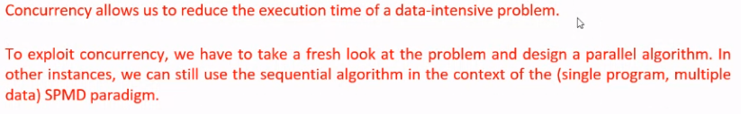

1. **Give a major difference between the basic models of grid and cloud computing.**

A major difference between the basic models of grid and cloud computing is that the former does not impose any restrictions regarding the heterogeneity of the computing platforms.

On the other hand, a computer cloud is a collection of homogeneous systems, systems with similar architecture and running under the same or very similar system software. The clients and the servers communicate through a network that itself can be congested. Transferring large volumes of data through the network can be time consuming; this is a major concern for data intensive applications in cloud computing. Communication through the network adds additional delay to the response time. Security becomes a major concern because the traffic between a client and a server can be intercepted.